CPS 510 - Database Systems I
Group 8
Assignment - 4_2

Amartya Chowdhury, 501153217
Mehrin Afroz Eshana, 501147157
Mohamad Al Walied Hasan Nafis, 501241332

VIEW Statements
View Statement 1:
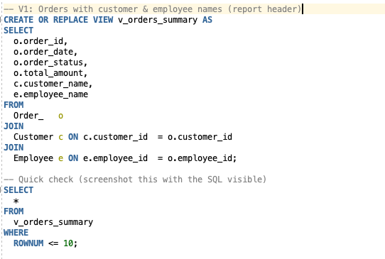
Result:
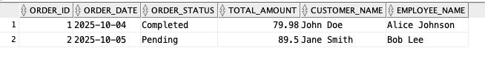

View Statement 2:
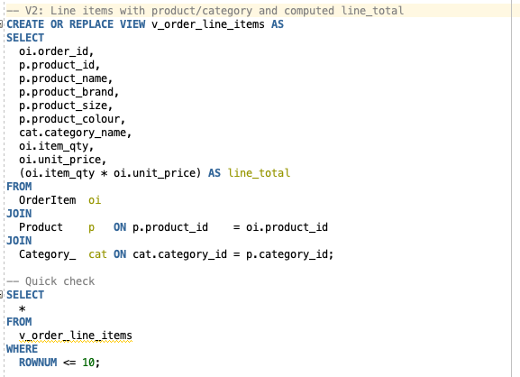
Result:
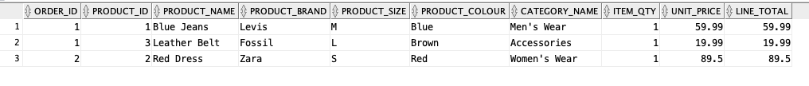

View Statement 3:
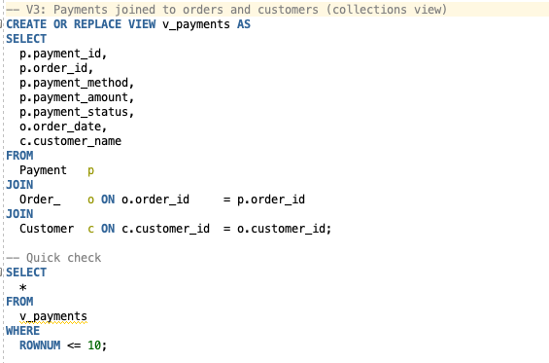
Result:

More Queries:
Query 1:
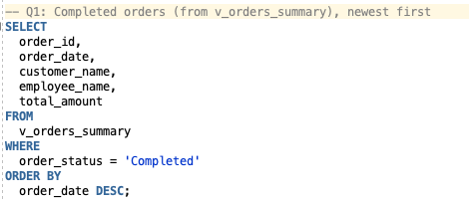
Result of Query 1:

Query 2:
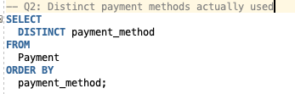
Result from Query 2:
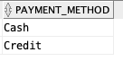

Query 3:
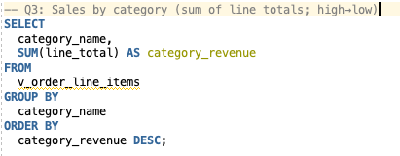
Result from Query 3:
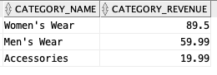

Query 4:
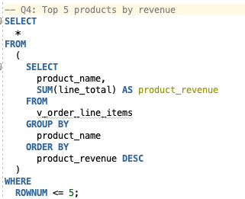
Result from Query 4:
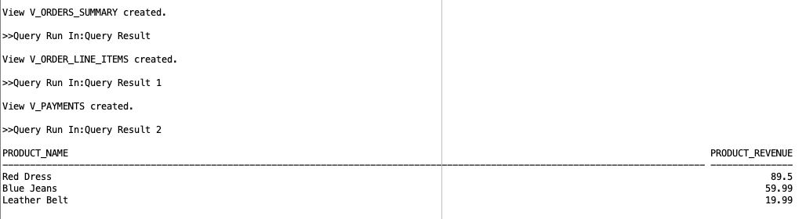

Query 5:
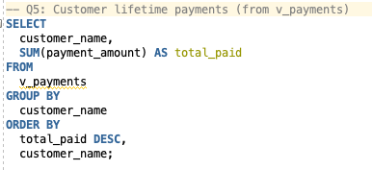
Result from Query 5:
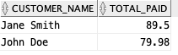

Query 6:
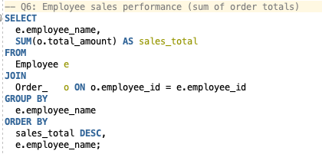
Results from Query 6:
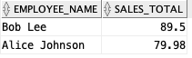

Query 7:
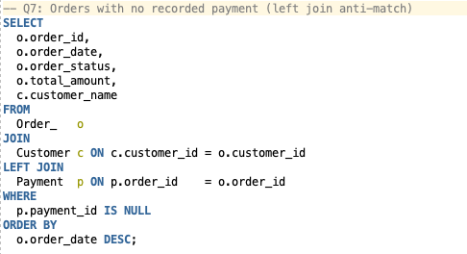
Result from Query 7:
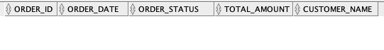

Query 8:
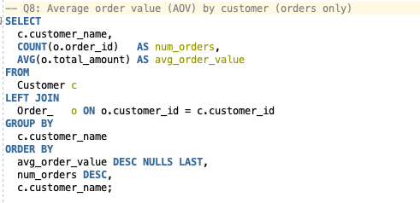
Result from Query 8:
